K-Means clustering and Elbow method
(Customer support ticket)
Imported Libraries
Python libraries, pandas for data handling, matplotlib for plotting, and KMeans from sklearn for clustering.”
Converting ‘First Response Time’ into Hours
First Response Time into proper datetime using pd.to_datetime().
New column ‘First Response Hours’ calculating how many hours passed from the earliest response time for converting time into a number so that K-means can understand it.
Handling Missing Values
Replaced missing values with the average of the column.
Features for Clustering
- Customer Age
- First Response Hours
K-Means Clustering
(Cluster 0, Cluster 1, and Cluster 2) based on two things: their Age and the First Response Time
Output
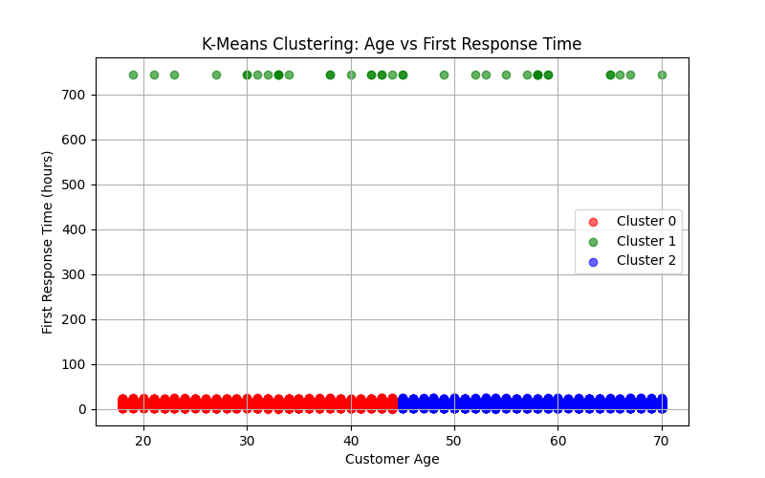

Cluster | Color | Customer Age Range | Interpretation
Cluster 1 | 🟢 Green | All Ages (Mostly 30+) | who had to wait a very long time for a first response (about a month). This group has a service issue.
Cluster 0 & 2 | 🔴 Red 🔵 Blue | Young and Older Ages (45+) | The Satisfied Groups (Fast Service): These two groups both received a very fast response time, (within the first day).

Cluster 0
Number of customers: 4261
Average Response Time (hours): 13
Cluster 1
Number of customers: 38
Average Response Time (hours): 744
Cluster 2
Number of customers: 4170
Average Response Time (hours): 14

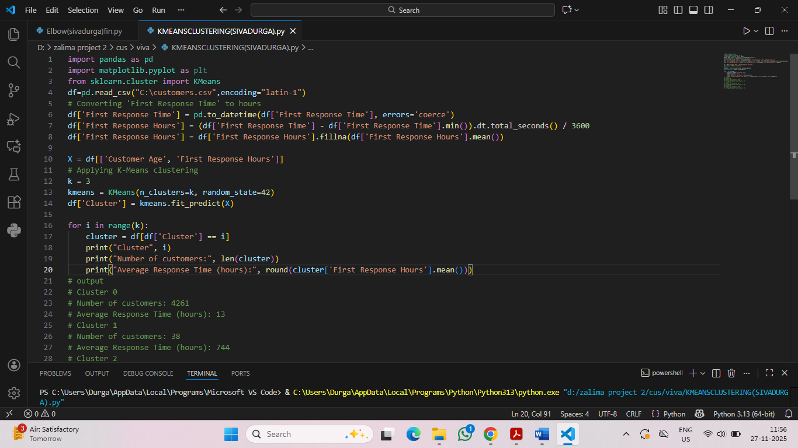

Elbow Method
inertialist = []
for k in range(1, 11):
kmeans = KMeans(n_clusters=k, random_state=42)
kmeans.fit(X)
inertialist.append(kmeans.inertia_)

Calculating the WCSS (within-cluster sum of squares) for cluster numbers from 1 to 10.
It helps to find “elbow point,” which shows the best number of clusters.
Output:
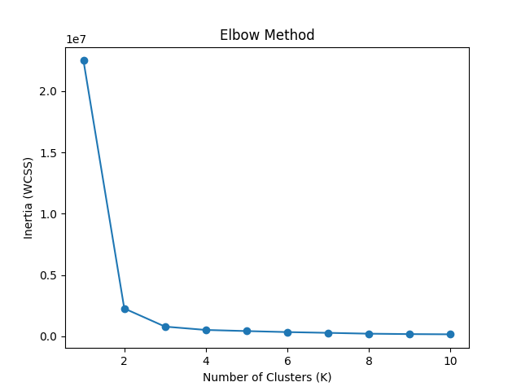
Plotted K (1 to 10) vs Inertia using a line graph.
The graph shows a sharp drop at first, then the curve flattens.
The point where it starts flattening is called the elbow, which suggests the optimal number of clusters.”
Result:
In the graph, sharp drop happens at K=2. After K=2, the decrease is gradual, the elbow is at 2 clusters.
- One cluster with fast response customers
- One cluster with slow response customers
